**15. Download iperf in laptop/phone and make sure they are in the same network. Try different iperf commands with TCP, UDP, bidirectional, reverse, multicast, parallel options and analyze the bandwidth and rate of transmission, delay, jitter, etc.**

**Server: Windows**

**Client: Linux**

**Server:**

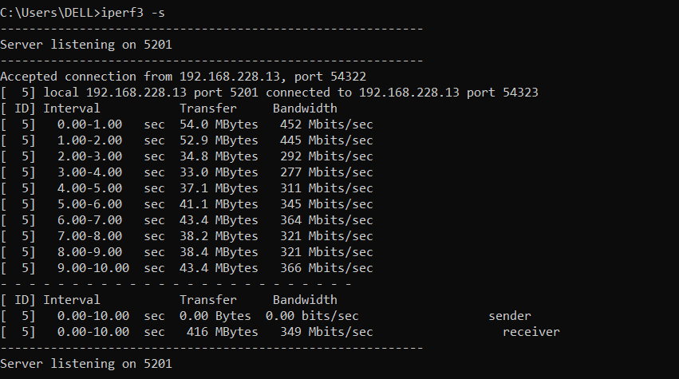

**TCP:**

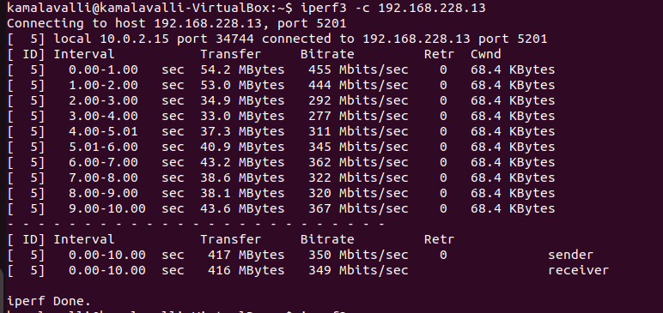

**UDP:**

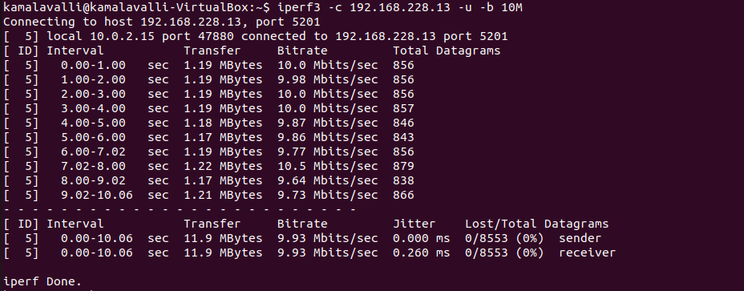

**Bidirectional Test** - Measure both upload and download speeds at the same time**:**

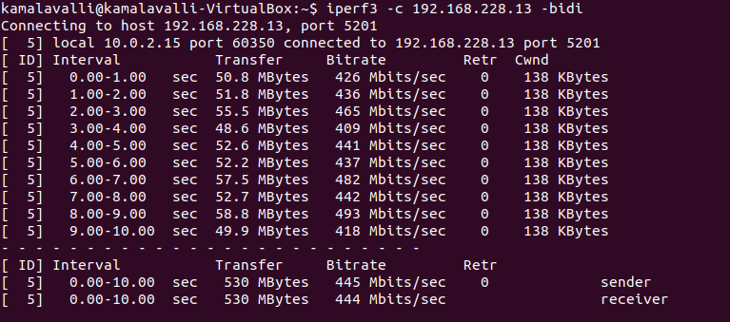

**Reverse Mode:**

To test **Windows → Linux** bandwidth

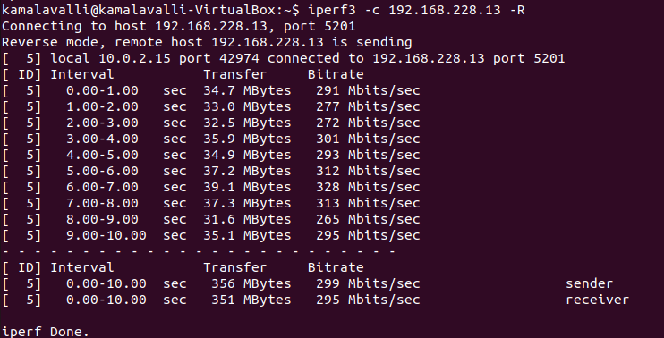

**Parallel Streams:**

To increase parallel connections and test performance

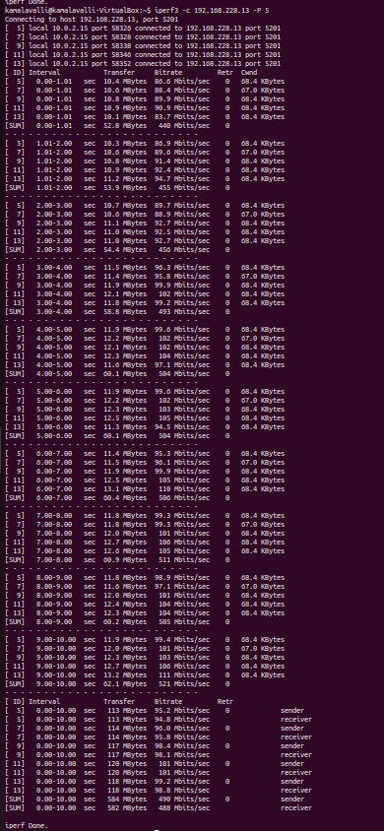

**Jitter & Packet Loss Analysis (UDP):**

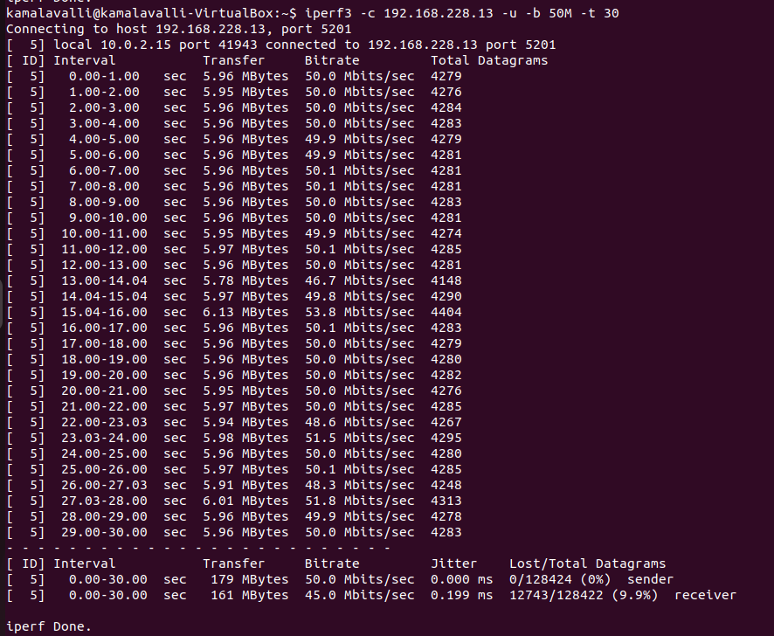

**Time:**

